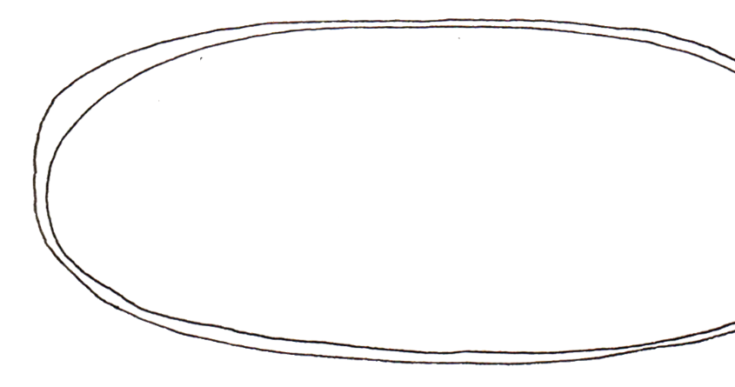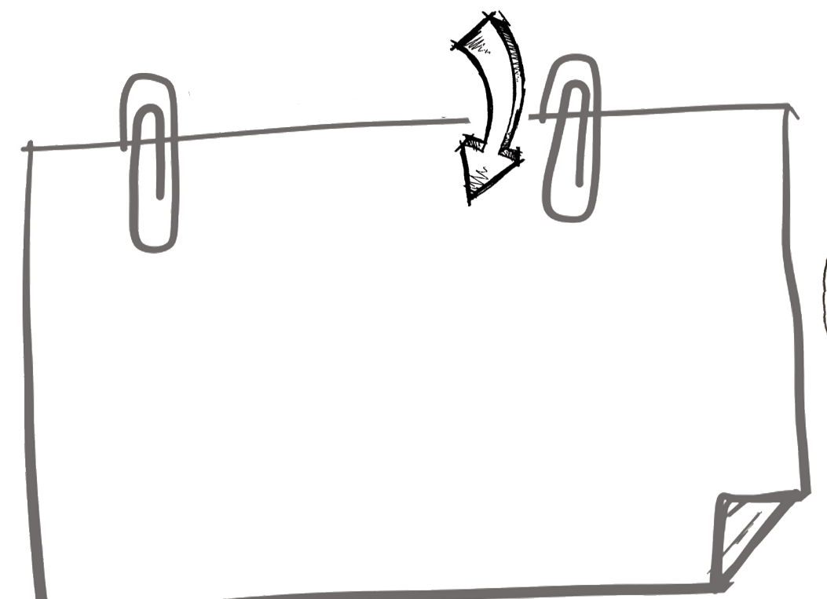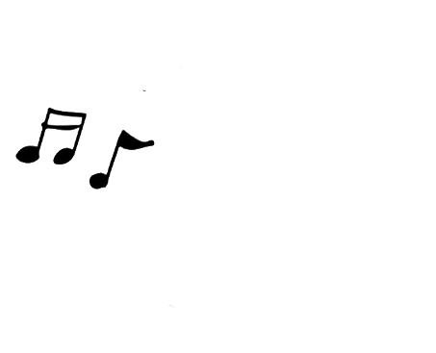

Westkirk Presbyterian Church

2700 Colby Woods Dr. | Urbandale | IA | 50323

515-253-0330 | www.westkirk.org

Book:___________________________________

Chapter:_____________________________

Verse:__________________________________

WHERE IN THE BIBLE?

WHO IS IN THE PASSAGE?

_________________________________

__________________________________

I DIDN’T UNDERSTAND?

________________________________________________________________________________________________________________________________________

**WHO’S SPEAKING:**

**DATE:**

**I LEARNED:**

**WHAT HAPPENED:**

**My favorite song:**

**WORDS I DON’T KNOW:**

**Use tally marks to show how many times you heard the pastor say these words.**

Jesus _______ Holy Spirit _________

God ______ Bible _________

Praise _______ resurrection _________

Salvation _______ John _________

Risen _______ King _________

**Things to pray about:**



The text below is LONG, but it is IMPORTANT. God gave Isaiah a glimpse of Himself in chapter 6, and then he asked Isaiah a very important question. How did Isaiah answer?

Use a Bible to fill in the missing words. See how much of this scripture you can memorize!